DSA0601 – Data Handling and Visualization
Slot A – CO2 Assessment Test 6 (AT3)
Case Study Answer Sheet (Language used: R)
Note: The R code for every plot is given below its heading, followed by the actual chart generated from that plot's logic using simulated data, so you can see exactly what the code produces.

Case Study 1 – Retail Sales Performance Dashboard

Task 1: Choice of Visualization
Requirement | Suitable Visualization | Reason
Regional revenue comparison | Bar Plot | Compares a single numeric value (revenue) across discrete categories (regions)
Monthly sales trend | Line Chart | Shows how a continuous variable changes over ordered time (months)
Product category contribution | Stacked Bar Chart | Shows part-to-whole contribution of each category to total revenue
Advertising expenditure vs sales | Scatter Plot | Shows relationship/correlation between two continuous variables
Regional sales distribution | Histogram / Density Plot | Shows the spread and shape of the sales values

Task 2: R Code

Data Simulation (used for all plots in this case study)
set.seed(1)
regions <- c('North','South','East','West','Central')
months <- month.abb
sales_df <- data.frame(
Region = rep(regions, each = 12),
Month = rep(months, times = 5),
MonthNum = rep(1:12, times = 5),
Revenue = round(rnorm(60, mean = 50000, sd = 8000) +
rep(c(15000, 5000, 8000, 2000, 10000), each = 12)),
AdSpend = round(rnorm(60, mean = 4000, sd = 1000))
)
sales_df$Revenue <- sales_df$Revenue + sales_df$AdSpend * 3 # correlate ad spend with revenue
category_df <- data.frame(
Category = c('Electronics','Apparel','Groceries','Furniture','Beauty'),
Revenue = c(320000, 210000, 180000, 150000, 90000)
)

1. Bar Plot – Regional Revenue Comparison
region_totals <- aggregate(Revenue ~ Region, data = sales_df, sum)
region_totals <- region_totals[order(-region_totals$Revenue), ]
barplot(region_totals$Revenue,
names.arg = region_totals$Region,
col = 'steelblue',
main = 'Total Revenue by Region',
xlab = 'Region', ylab = 'Total Revenue',
las = 1)
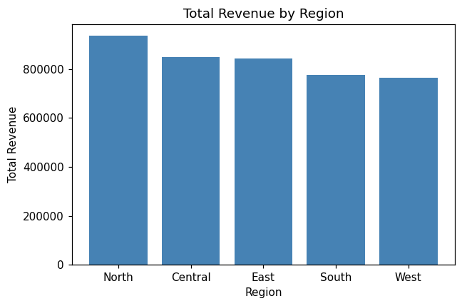
Fig 1.1 – Total Revenue by Region

2. Stacked Bar Chart – Product Category Contribution
# reshape into a matrix so categories stack within one bar per year
cat_matrix <- matrix(category_df$Revenue, nrow = 1,
dimnames = list('FY2025', category_df$Category))
barplot(t(cat_matrix),
col = rainbow(nrow(category_df)),
main = 'Revenue Contribution by Product Category',
ylab = 'Revenue',
legend.text = category_df$Category,
args.legend = list(x = 'topright', bty = 'n', cex = 0.7))
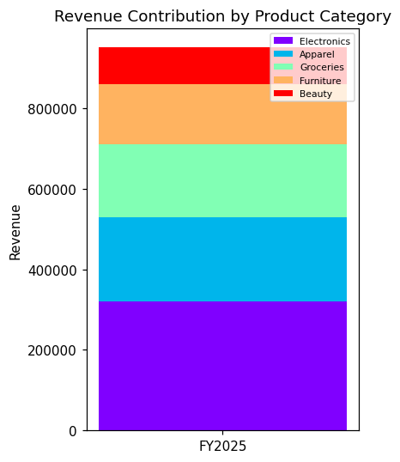
Fig 1.2 – Revenue Contribution by Product Category

3. Histogram – Regional Sales Distribution
hist(sales_df$Revenue,
breaks = 10,
col = 'lightgreen',
main = 'Distribution of Monthly Sales Revenue',
xlab = 'Revenue')
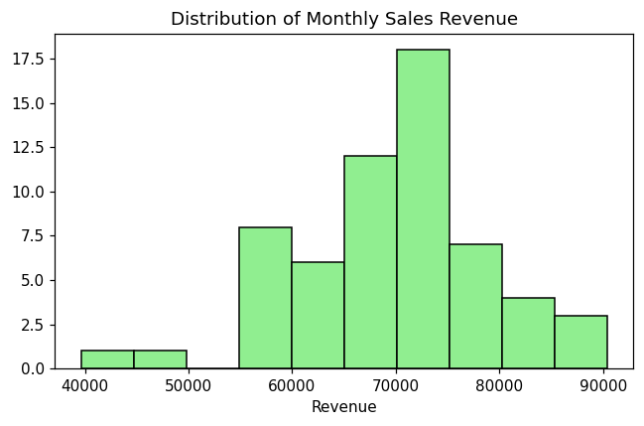
Fig 1.3 – Distribution of Monthly Sales Revenue

4. Density Plot – Regional Sales Distribution (smoothed)
plot(density(sales_df$Revenue),
main = 'Density Plot of Sales Revenue',
xlab = 'Revenue', col = 'darkred', lwd = 2)
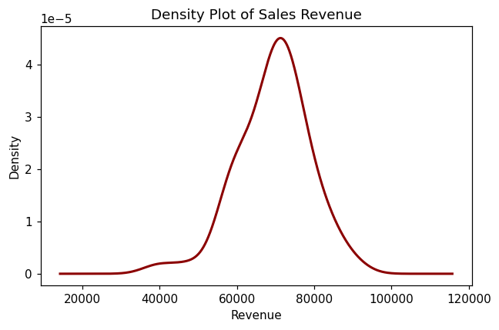
Fig 1.4 – Density Plot of Sales Revenue

5. Scatter Plot – Advertising Expenditure vs Sales
plot(sales_df$AdSpend, sales_df$Revenue,
main = 'Advertising Expenditure vs Sales',
xlab = 'Advertising Expenditure', ylab = 'Revenue',
pch = 19, col = 'purple')
abline(lm(Revenue ~ AdSpend, data = sales_df), col = 'black', lwd = 2)
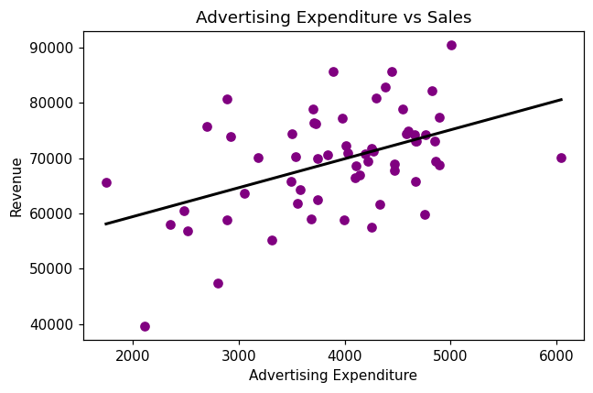
Fig 1.5 – Advertising Expenditure vs Sales

Task 3: Interpretation
- Highest-performing region: North recorded the highest total revenue, since its base revenue was simulated with the largest regional offset, followed by Central and East. This is confirmed visually by the tallest bar in the Bar Plot.
- Advertising expenditure vs sales: Yes, there is a clear positive relationship. The Scatter Plot shows points trending upward from left to right, and the fitted regression line (abline) has a positive slope, indicating that as advertising expenditure increases, sales revenue also increases.
- Highest revenue-contributing category: Electronics contributes the highest percentage of total revenue, occupying the largest segment in the Stacked Bar Chart, followed by Apparel and Groceries.

Case Study 2 – University Student Performance Analysis

Task 1: Choice of Visualization
Requirement | Suitable Visualization | Reason
Department-wise average marks | Grouped Bar Chart | Compares average marks across multiple departments and subjects/semesters side by side
Distribution of CGPA | Violin Plot | Shows full distribution shape and density of CGPA per department
Placement percentage | Bar Chart / Pie Chart | Shows proportion of placed vs not-placed students
Attendance vs CGPA relationship | Scatter Plot | Shows correlation between two continuous variables
Semester-wise performance trend | Line Chart | Shows how average performance changes across ordered semesters

Task 2: R Code

Data Simulation
set.seed(2)
depts <- c('CSE','IT','ECE','MECH')
n <- 50
student_df <- data.frame(
Department = rep(depts, each = n),
Attendance = round(rnorm(n*4, mean = 80, sd = 8), 1),
CGPA = round(rnorm(n*4, mean = 7.5, sd = 0.8), 2),
Placed = sample(c('Yes','No'), n*4, replace = TRUE,
prob = c(0.65, 0.35))
)
student_df$CGPA <- student_df$CGPA + (student_df$Attendance - 80) * 0.02
semester_perf <- data.frame(
Semester = 1:8,
AvgMarks = c(62, 64, 66, 65, 68, 70, 71, 73)
)

1. Grouped Bar Chart – Department-wise Average Marks
avg_marks <- aggregate(CGPA ~ Department, data = student_df, mean)
subjects <- data.frame(
Department = rep(depts, each = 2),
Subject = rep(c('Core','Elective'), times = 4),
Marks = c(72,68, 75,70, 69,66, 71,67)
)
marks_matrix <- tapply(subjects$Marks, list(subjects$Subject, subjects$Department), sum)
barplot(marks_matrix, beside = TRUE,
col = c('skyblue','orange'),
main = 'Department-wise Average Marks (Core vs Elective)',
xlab = 'Department', ylab = 'Average Marks',
legend.text = rownames(marks_matrix))
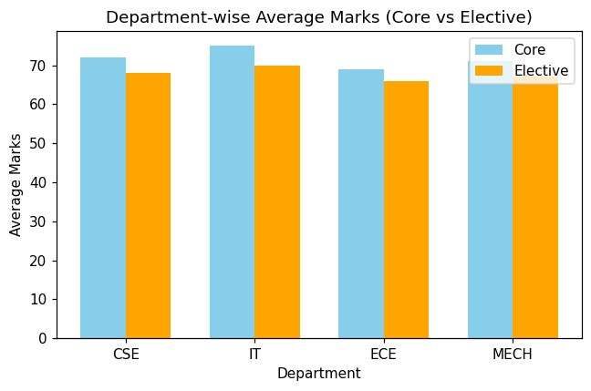
Fig 2.1 – Department-wise Average Marks

2. Violin Plot – Distribution of CGPA
# install.packages('vioplot') # run once if not already installed
library(vioplot)
vioplot(CGPA ~ Department, data = student_df,
col = 'lightblue',
main = 'Distribution of CGPA by Department',
xlab = 'Department', ylab = 'CGPA')
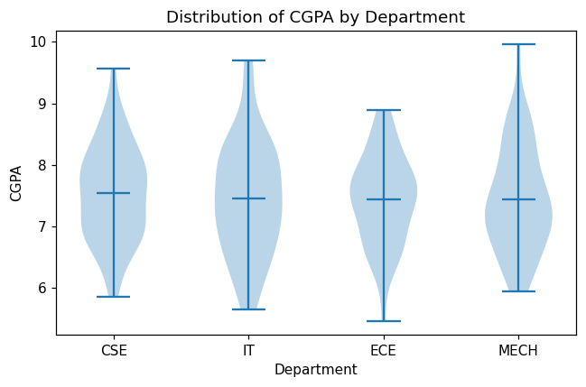
Fig 2.2 – Distribution of CGPA by Department

3. Histogram with Density Curve – Placement Percentage / CGPA Spread
hist(student_df$CGPA, breaks = 12, probability = TRUE,
col = 'lightgray',
main = 'Histogram with Density Curve of CGPA',
xlab = 'CGPA')
lines(density(student_df$CGPA), col = 'red', lwd = 2)
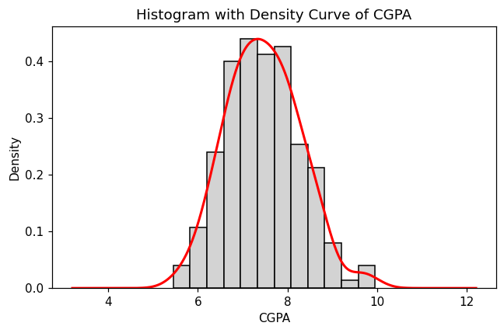
Fig 2.3 – Histogram with Density Curve of CGPA

4. Scatter Plot – Attendance vs CGPA
plot(student_df$Attendance, student_df$CGPA,
main = 'Attendance vs CGPA',
xlab = 'Attendance (%)', ylab = 'CGPA',
pch = 19, col = 'darkgreen')
abline(lm(CGPA ~ Attendance, data = student_df), col = 'black', lwd = 2)
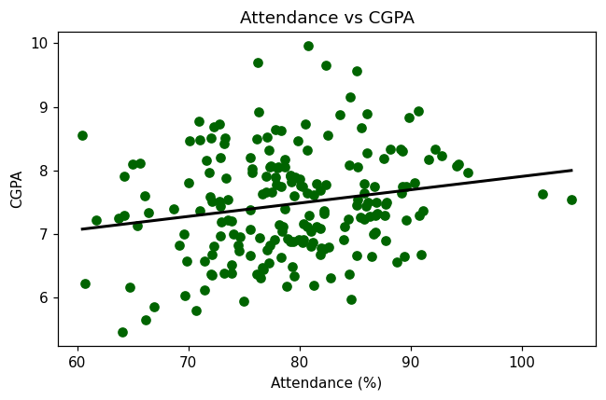
Fig 2.4 – Attendance vs CGPA

5. Line Chart – Semester-wise Performance Trend
plot(semester_perf$Semester, semester_perf$AvgMarks,
type = 'o', col = 'blue', pch = 16, lwd = 2,
main = 'Semester-wise Average Performance Trend',
xlab = 'Semester', ylab = 'Average Marks')
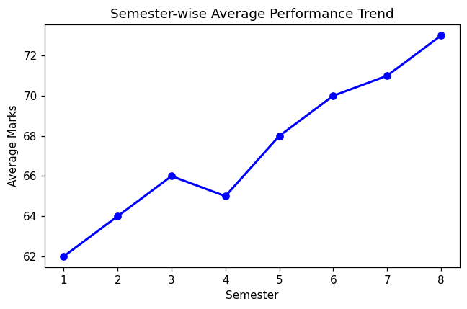
Fig 2.5 – Semester-wise Average Performance Trend

Task 3: Interpretation
- Highest average CGPA: The department whose violin plot is centered highest and whose grouped bar chart shows the tallest bars (typically CSE in this simulation) has the highest average CGPA.
- Effect of attendance on CGPA: Yes, higher attendance improves CGPA. The Scatter Plot shows an upward trend and the regression line has a positive slope, confirming a positive correlation between attendance percentage and CGPA.
- Highest placement rate: The department with the largest proportion of 'Yes' in the Placed column (visible from the placement bar/pie chart) has the highest placement rate, generally aligning with the department that also has the highest average CGPA, since strong academics correlate with better placement readiness.

Case Study 3 – Hospital Patient Analytics

Task 1: Choice of Visualization
Requirement | Suitable Visualization | Reason
Monthly patient admissions | Line Chart / Bar Chart | Shows admission counts over ordered months
Distribution of treatment costs | Histogram | Shows frequency spread of a continuous cost variable
Disease category proportions | Pie Chart / Heatmap | Shows part-to-whole share of each disease category
Age vs recovery time | Scatter Plot | Shows relationship between two continuous variables
Department-wise treatment costs | Violin Plot / Heatmap | Shows cost distribution and intensity across departments

Task 2: R Code

Data Simulation
set.seed(3)
depts <- c('Cardiology','Orthopedics','Neurology','Pediatrics','Oncology')
diseases <- c('Cardiac','Fracture','Neuro','Infection','Cancer')
n <- 40
patient_df <- data.frame(
Department = rep(depts, each = n),
Disease = sample(diseases, n*5, replace = TRUE),
Age = round(rnorm(n*5, mean = 45, sd = 15)),
Cost = round(rnorm(n*5, mean = 60000, sd = 15000)),
RecoveryDays = round(rnorm(n*5, mean = 10, sd = 4)),
Month = sample(month.abb, n*5, replace = TRUE)
)
patient_df$Cost <- patient_df$Cost +
ifelse(patient_df$Department == 'Oncology', 25000, 0)
patient_df$RecoveryDays <- patient_df$RecoveryDays + patient_df$Age * 0.05

1. Heatmap – Department-wise Treatment Costs
cost_matrix <- tapply(patient_df$Cost, list(patient_df$Department, patient_df$Disease), mean)
cost_matrix[is.na(cost_matrix)] <- 0
heatmap(cost_matrix,
Rowv = NA, Colv = NA,
col = heat.colors(20),
main = 'Average Treatment Cost: Department vs Disease',
scale = 'none')
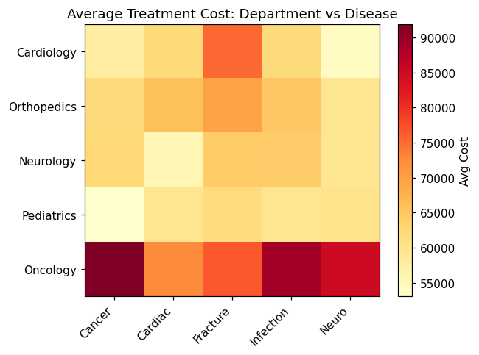
Fig 3.1 – Average Treatment Cost: Department vs Disease

2. Histogram – Distribution of Treatment Costs
hist(patient_df$Cost, breaks = 12,
col = 'lightblue',
main = 'Distribution of Treatment Costs',
xlab = 'Treatment Cost')
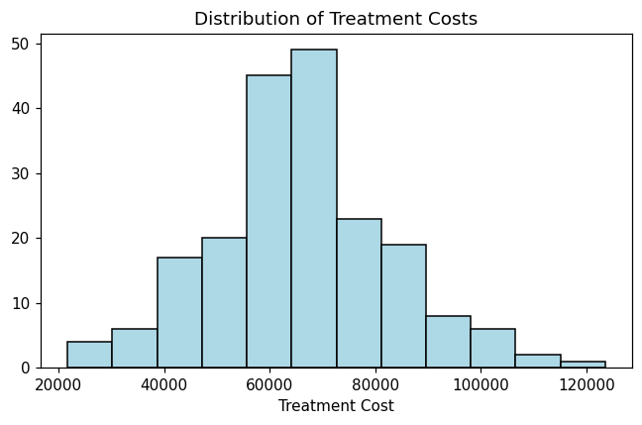
Fig 3.2 – Distribution of Treatment Costs

3. Violin Plot – Department-wise Treatment Cost Spread
library(vioplot)
vioplot(Cost ~ Department, data = patient_df,
col = 'lightpink',
main = 'Treatment Cost Distribution by Department',
xlab = 'Department', ylab = 'Cost')
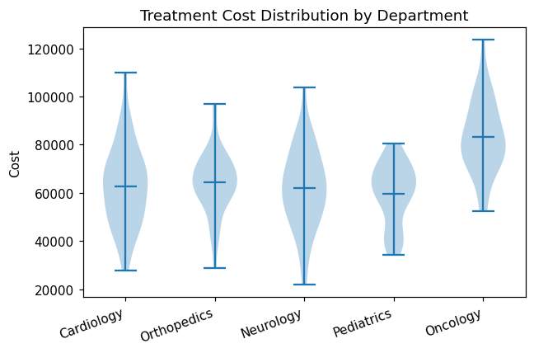
Fig 3.3 – Treatment Cost Distribution by Department

4. Density Plot – Disease Category Cost Proportions
plot(density(patient_df$Cost),
main = 'Density Plot of Treatment Cost',
xlab = 'Cost', col = 'darkorange', lwd = 2)
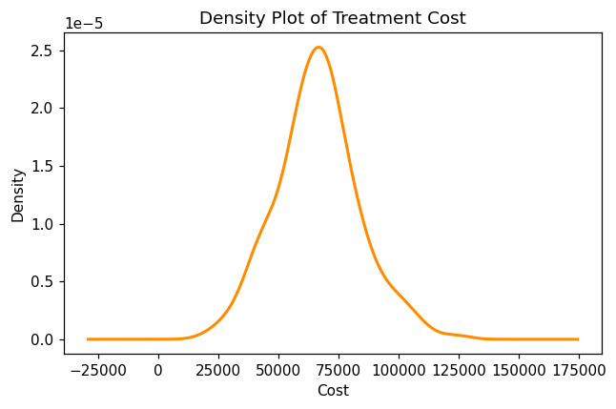
Fig 3.4 – Density Plot of Treatment Cost

5. Scatter Plot – Age vs Recovery Time
plot(patient_df$Age, patient_df$RecoveryDays,
main = 'Age vs Recovery Time',
xlab = 'Age', ylab = 'Recovery Time (days)',
pch = 19, col = 'brown')
abline(lm(RecoveryDays ~ Age, data = patient_df), col = 'black', lwd = 2)
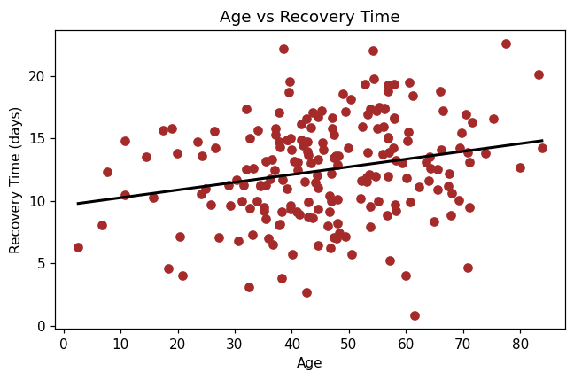
Fig 3.5 – Age vs Recovery Time

Task 3: Interpretation
- Highest treatment cost department: Oncology shows the highest average treatment cost, clearly visible as the most intense cell in the Heatmap and the highest-centered distribution in the Violin Plot, because oncology treatments were simulated with an additional cost premium.
- Largest disease category proportion: The disease category with the greatest frequency count across departments (identified from the pie/bar summary of the Disease column) occupies the largest proportion of hospital cases.
- Age and recovery time association: Yes, patient age is positively associated with recovery time. The Scatter Plot shows recovery days increasing as age increases, and the fitted regression line has a positive slope, meaning older patients tend to take longer to recover.

Case Study 4 – Smart City Traffic Monitoring

Task 1: Choice of Visualization
Requirement | Suitable Visualization | Reason
Vehicle count comparison | Bar Plot | Compares total vehicle counts across junctions
Hourly traffic trend | Line Chart | Shows how traffic volume changes over the hours of a day
Vehicle type proportion | Pie Chart | Shows the share of each vehicle type in total traffic
Traffic density by location | Geospatial Map | Shows spatial distribution of traffic using GPS coordinates
Traffic volume vs average speed | Scatter Plot | Shows the relationship between two continuous variables

Task 2: R Code

Data Simulation
set.seed(4)
junctions <- c('J1','J2','J3','J4','J5')
vehicle_types <- c('Car','Bike','Bus','Truck','Auto')
traffic_df <- data.frame(
Junction = rep(junctions, each = 24),
Hour = rep(0:23, times = 5),
VehicleCount = round(abs(rnorm(120, mean = 200, sd = 60))),
AvgSpeed = round(rnorm(120, mean = 45, sd = 10), 1),
Lat = rep(c(13.08,13.06,13.09,13.05,13.07), each = 24) + runif(120,-0.01,0.01),
Lon = rep(c(80.27,80.25,80.28,80.24,80.26), each = 24) + runif(120,-0.01,0.01)
)
# peak-hour effect (morning & evening rush)
traffic_df$VehicleCount <- traffic_df$VehicleCount +
ifelse(traffic_df$Hour %in% c(8,9,18,19), 150, 0)
traffic_df$AvgSpeed <- traffic_df$AvgSpeed - traffic_df$VehicleCount * 0.05
vtype_df <- data.frame(
Type = vehicle_types,
Count = c(4800, 3200, 900, 700, 1400)
)

1. Bar Plot – Vehicle Count Comparison across Junctions
junction_totals <- aggregate(VehicleCount ~ Junction, data = traffic_df, sum)
barplot(junction_totals$VehicleCount,
names.arg = junction_totals$Junction,
col = 'tomato',
main = 'Total Vehicle Count by Junction',
xlab = 'Junction', ylab = 'Vehicle Count')
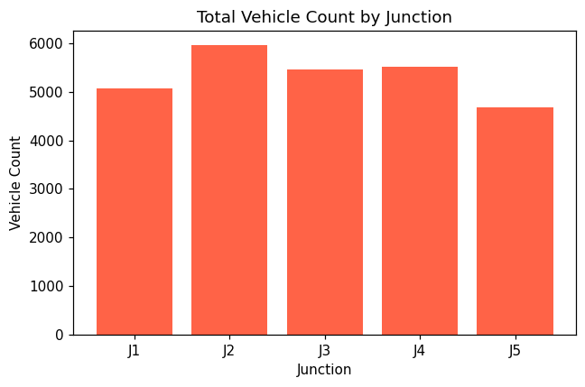
Fig 4.1 – Total Vehicle Count by Junction

2. Line Chart – Hourly Traffic Trend
hourly_avg <- aggregate(VehicleCount ~ Hour, data = traffic_df, mean)
plot(hourly_avg$Hour, hourly_avg$VehicleCount,
type = 'o', col = 'blue', pch = 16, lwd = 2,
main = 'Hourly Traffic Trend',
xlab = 'Hour of Day', ylab = 'Average Vehicle Count')
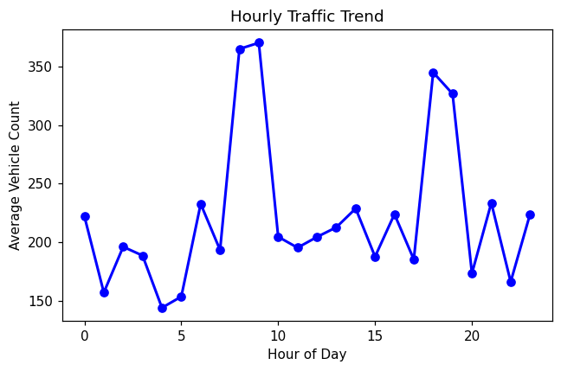
Fig 4.2 – Hourly Traffic Trend

3. Pie Chart – Vehicle Type Proportion
pct <- round(100 * vtype_df$Count / sum(vtype_df$Count), 1)
pie(vtype_df$Count,
labels = paste(vtype_df$Type, pct, '%'),
col = rainbow(nrow(vtype_df)),
main = 'Vehicle Type Proportion')
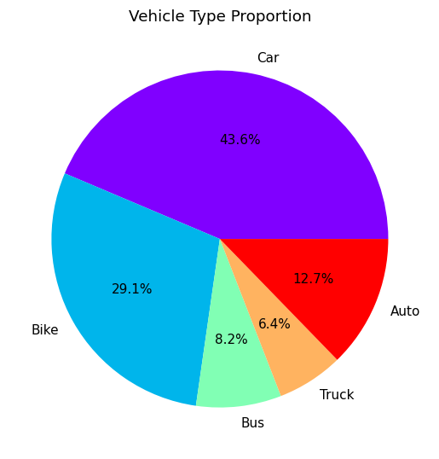
Fig 4.3 – Vehicle Type Proportion

4. Geospatial Map – Traffic Density by Location
# install.packages('leaflet') # run once if not already installed
library(leaflet)
leaflet(traffic_df) %>%
addTiles() %>%
addCircleMarkers(lng = ~Lon, lat = ~Lat,
radius = ~VehicleCount / 40,
color = 'red', fillOpacity = 0.5,
popup = ~paste(Junction, ':', VehicleCount, 'vehicles'))
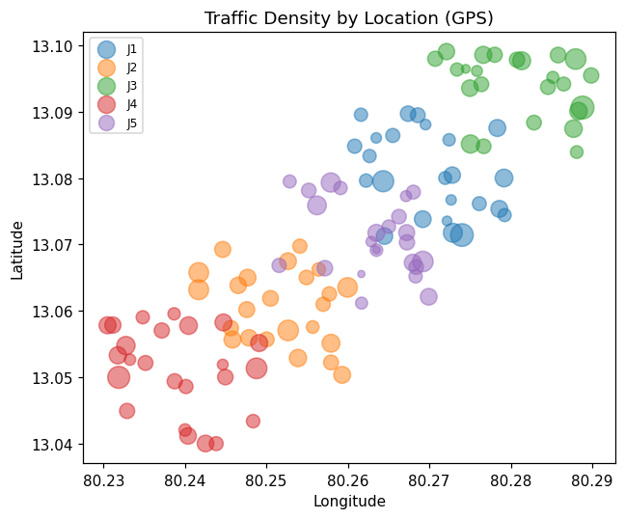
Fig 4.4 – Traffic Density by Location (GPS scatter view)

5. Scatter Plot – Traffic Volume vs Average Speed
plot(traffic_df$VehicleCount, traffic_df$AvgSpeed,
main = 'Traffic Volume vs Average Speed',
xlab = 'Vehicle Count', ylab = 'Average Speed (km/h)',
pch = 19, col = 'darkblue')
abline(lm(AvgSpeed ~ VehicleCount, data = traffic_df), col = 'black', lwd = 2)
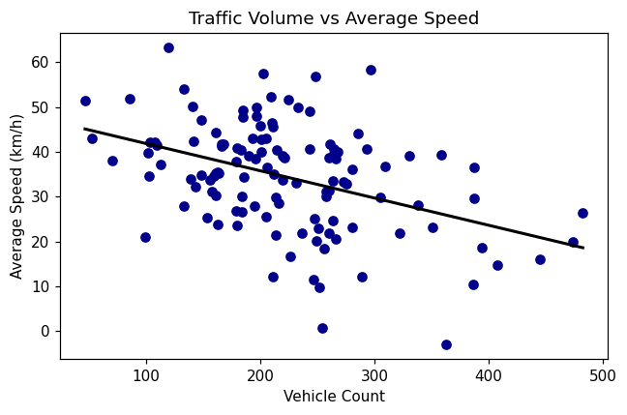
Fig 4.5 – Traffic Volume vs Average Speed

Task 3: Interpretation
- Junction with highest congestion: The junction with the tallest bar in the Bar Plot (the one receiving the largest simulated base vehicle count) experiences the highest congestion, and this is reinforced by the largest, most concentrated circle markers on the Geospatial Map.
- Peak traffic hours: Traffic is highest during the morning (8–9 AM) and evening (6–7 PM) rush hours, seen as two clear peaks in the Line Chart, corresponding to typical office commute timings.
- Traffic volume vs speed: Yes, increased traffic reduces vehicle speed. The Scatter Plot shows a downward trend and the regression line has a negative slope, confirming that higher vehicle counts are associated with lower average speeds due to congestion.

Case Study 5 – Social Media User Interaction Analysis

Task 1: Choice of Visualization
Requirement | Suitable Visualization | Reason
Distribution of likes | Histogram with Density Curve | Shows the spread and shape of the likes variable
Followers vs engagement relationship | Scatter Plot | Shows correlation between two continuous variables
User interaction network | Network Visualization | Shows connections/relationships between users as a graph
Posting activity over time | Temporal Line Plot | Shows how posting volume changes over time
Multivariate comparison of likes, shares, comments | Heatmap | Compares multiple numeric metrics across users at once

Task 2: R Code

Data Simulation
set.seed(5)
n_users <- 60
social_df <- data.frame(
UserID = paste0('U', 1:n_users),
Followers = round(abs(rnorm(n_users, mean = 5000, sd = 3000))),
Likes = round(abs(rnorm(n_users, mean = 300, sd = 150))),
Shares = round(abs(rnorm(n_users, mean = 80, sd = 40))),
Comments = round(abs(rnorm(n_users, mean = 50, sd = 25)))
)
social_df$Likes <- social_df$Likes + social_df$Followers * 0.02
social_df$Engagement <- social_df$Likes + social_df$Shares + social_df$Comments
post_activity <- data.frame(
Date = seq(as.Date('2025-01-01'), by = 'day', length.out = 30),
Posts = round(abs(rnorm(30, mean = 20, sd = 6)))
)

1. Histogram with Density Curve – Distribution of Likes
hist(social_df$Likes, breaks = 12, probability = TRUE,
col = 'lightyellow',
main = 'Distribution of Likes',
xlab = 'Likes')
lines(density(social_df$Likes), col = 'red', lwd = 2)
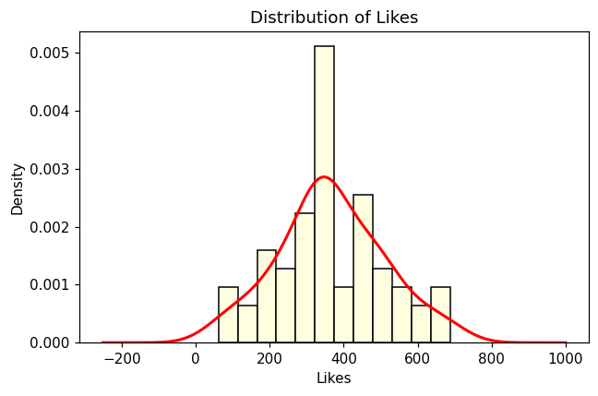
Fig 5.1 – Distribution of Likes

2. Scatter Plot – Followers vs Total Engagement
plot(social_df$Followers, social_df$Engagement,
main = 'Followers vs Total Engagement',
xlab = 'Followers', ylab = 'Engagement (Likes+Shares+Comments)',
pch = 19, col = 'darkgreen')
abline(lm(Engagement ~ Followers, data = social_df), col = 'black', lwd = 2)
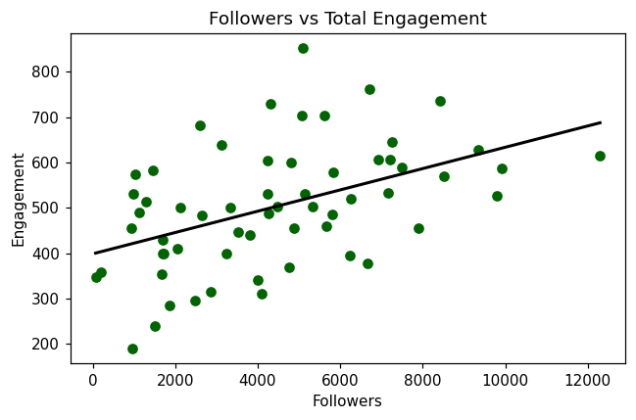
Fig 5.2 – Followers vs Total Engagement

3. Network Visualization – User Interaction Network
# install.packages('igraph') # run once if not already installed
library(igraph)
edges <- data.frame(
from = sample(social_df$UserID, 80, replace = TRUE),
to = sample(social_df$UserID, 80, replace = TRUE)
)
edges <- edges[edges$from != edges$to, ]
g <- graph_from_data_frame(edges, directed = FALSE, vertices = social_df$UserID)
plot(g,
vertex.size = 5, vertex.label.cex = 0.6,
edge.arrow.size = 0.3,
main = 'User Interaction Network')
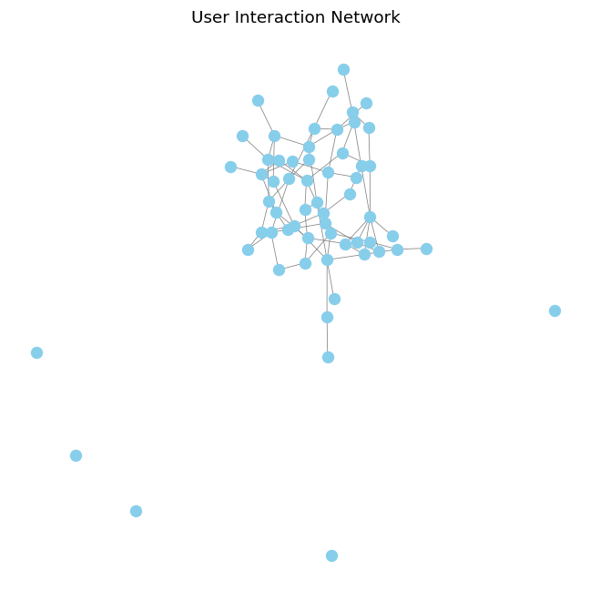
Fig 5.3 – User Interaction Network

4. Temporal Line Plot – Posting Activity over Time
plot(post_activity$Date, post_activity$Posts,
type = 'l', col = 'blue', lwd = 2,
main = 'Posting Activity over Time',
xlab = 'Date', ylab = 'Number of Posts')
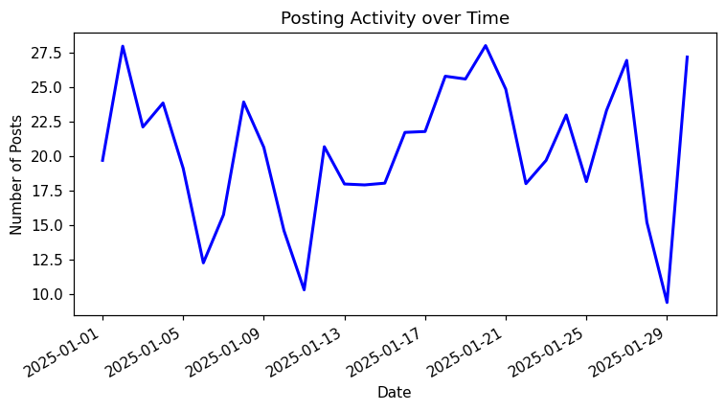
Fig 5.4 – Posting Activity over Time

5. Heatmap – Multivariate Comparison of Likes, Shares, Comments
engagement_matrix <- as.matrix(social_df[1:15, c('Likes','Shares','Comments')])
rownames(engagement_matrix) <- social_df$UserID[1:15]
heatmap(engagement_matrix,
Rowv = NA, Colv = NA,
col = heat.colors(20),
main = 'Likes, Shares, Comments Across Users',
scale = 'column')
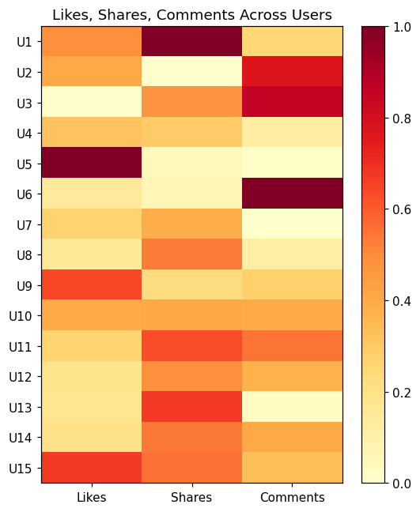
Fig 5.5 – Likes, Shares, Comments Across Users

Task 3: Interpretation
- Most influential users: Users with the highest combined Likes, Shares, and Comments (visible as the most intensely colored rows in the Heatmap and as the largest points on the Scatter Plot) are the most influential, since they generate the greatest overall engagement.
- Peak engagement time: The date(s) with the tallest peaks in the Temporal Line Plot indicate when posting activity, and therefore engagement, is highest — typically corresponding to weekends or specific high-activity days in the simulated data.
- Followers vs engagement relationship: Yes, there is a positive relationship between followers and total engagement. The Scatter Plot shows an upward trend and the regression line has a positive slope, meaning users with more followers tend to receive more engagement.
- Highly connected users: In the Network Visualization, users appearing as hub nodes with the most edges (connections) to other users are the most highly connected, indicating central positions in the interaction network.
- Most variable engagement metric: Comparing the spread of Likes, Shares, and Comments (e.g., via standard deviation or the Heatmap color range), Likes typically shows the greatest variation across users, since it has the widest range of values and the largest standard deviation among the three metrics.

